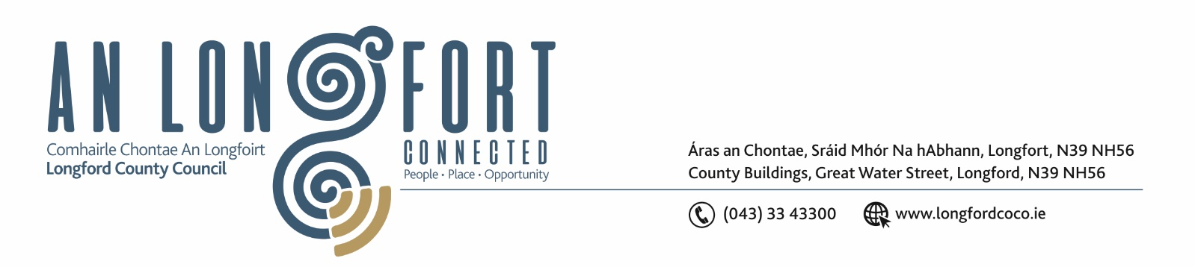

Please note: meeting will be held in Council Chamber, Aras an Chontae and via Microsoft Teams.

19ú Samhain 2024.

Chuig: Gach Ball don Chomhairle.

A Chomhairleoir,

You are requested to attend the Finance Committee Meeting of Longford County Council to be held on Monday 2 December 2024 at 4pm in Council Chamber, Aras an Chontae and via Microsoft Teams to transact business as set out on the agenda hereunder.

Mise le meas,

__________________
Claire McNabola,
Meetings Administrator.

C L A R

- Consideration of Draft Annual Budget 2025 – enclosed.


